**Faculty of Computing**

**Year 2 Semester 1 (2025)**

**IT2120 - Probability and Statistics**

**IT24104068**

**Lab Sheet 06**

**1.An IT company claims that their newly developed learning platform improves student performance in online tests. According to previous data, 85% of students who used the platform passed their online tests. A batch of 50 students is selected at random who have completed the course using this platform. Let X denote the number of students who passed the test out of 50 students.**

**i. What is the distribution of X?**

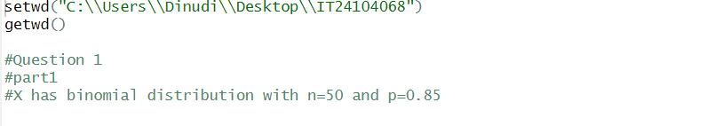

**ii. What is the probability that at least 47 students passed the test?**

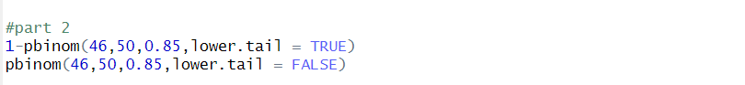

**2. A call center receives an average of 12 customer calls per hour.**

**i. What is the random variable (X) for the problem?**

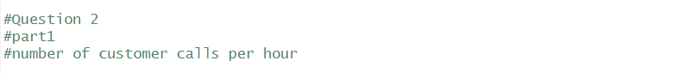

**ii. What is the distribution of X?**

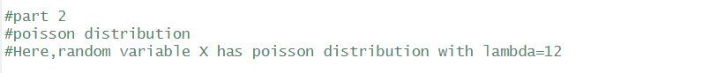

**iii. What is the probability that exactly 15 calls are received in an hour?**

